Completing Education Access Register

Double click on the spreadsheet where you want to enter the attendance mark under the correct date and time of day (the two spaces underneath each date represent ‘morning’ and ‘afternoon’)
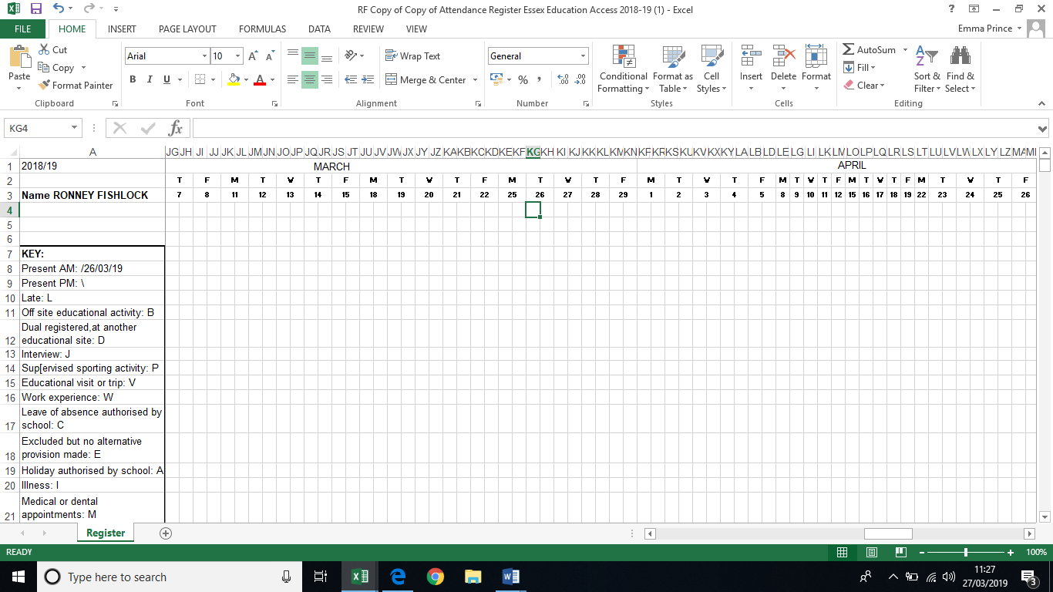

Enter in your mark ( / for morning and \ for afternoon)

Save your register – you can then return to it each time you need to add in another attendance mark.
The register should then be sent to your contact at the school, myself and provision@essex.gov.uk
They ask for the register to be sent each day that you see a child.

