Engaging Children and Young People During Online Sessions

A Guide for Practitioners
Including Resources

#TeamEvolve

Tips for engaging young people online
Before you start
Go through your Practitioner Checklist to ensure you have covered all points ahead of starting.
First session – suggested structure
Remember to refer to your Practitioner Checklist as needed.
Introduction: Introduce Evolve Intervention, what your role is at Evolve and how your sessions will work.
Move onto Data Consent:
FOR FIF-XTRA:
- Check that data form has been filled out and ticked/signed. Explain what data will be shared about them if they are unsure.
- If a person has not consented to data sharing, please make them aware that if a safeguarding issue arises you will have to share certain data with relevant people/organisations.
- Emphasise our confidentiality agreement and reassure the person you are working with that everything remains confidential unless you feel they or someone they talk about may be at risk.
FOR ALL OTHER INTERVENTIONS:
Go through the ‘Agreement to Access Services’ Form as you normally would in person.

Fill out any evaluation forms needed.
Set some “Ground Rules” together.
If the child/young person is engaged after all the “housekeeping” you may want to do an icebreaker worksheet or game.
Tip: ask them to help you to fill out a “Getting to know you” worksheet, you could both share things about yourself (be mindful of self-disclosure) such as likes dislikes etc, nothing too personal.
At the end of the session ask them how they are feeling and how they felt the session went.
Remind them of the details of the next session and thank them for their time.
Once session is ended go through your Practitioner Checklist to ensure you have ticked all the boxes.
Second session:
Option 1: During your next sessions if the child/young person is engaged you may want to do some goal setting work. When you understand any changes/challenges or improvements a young person wants to achieve you may want to help them set a goal plan. Doing a small goal each week that feeds into the bigger goal that they are trying to achieve.
Option 2: If a child or young person is reluctant to engage maybe try just playing a game with them. This can help you get to know them and begin to form a connection without them feeling under any pressure. Resources for games are available attached to these guidelines below.
Ideas for Models of Working
If the child or young person is engaging and has expressed the desire to improve or change, these 2 models of working through session in a more structured way may help you support them to achieve their goals. Please note these models are just a guide. They are tailored to older children who are willing to engage in goal setting to help empower them to make their own changes. You can adapt them to younger children if you wish and if you feel they are appropriate.
Here are two examples of models you may want to use in this instance to engage a young person during their online session.

THE PACE AND LEAD MODEL:
Begin your session by including 3 fact-based statements.
For example: It’s Tuesday morning...we had our third session this time last week, last week we spoke about….
Then follow this up with an open suggestion…Wouldn’t it be great if….
Fact base introductions can build trust and confidence in a relationship.

THE WDEP MODEL:
WANT: What do you want to gain from our sessions together?
DOING: What are the things that you can do to make your goals achievable?
EVALUATION: Are the sessions working for you? Are the things your doing working? What do you think could work better? What are you enjoying?
PLAN: Now that you have an idea of what you want to achieve/change, and what things are working for you, what plans are you going to put into place to keep going?
This model helps to empower young people to give them the autonomy and encourage them to become problem solvers. It can help grow resilience and confidence. It encourages young people to understand that they can control the outcome of something that challenges them.

FINAL IMPORTANT TIP
Don’t be hard on yourself. The whole world is going through a new transition of remote work and online delivery. Have a sense of humour, remember things WILL go wrong but it won’t be the end of the world.
If a young person doesn’t want to engage in sessions, you HAVE NOT failed. Just as we find this new way of working a little challenging and nerve wracking sometimes, young people do too. Just always reassure them that if they are not ready then they are always welcome to get in touch when they are. Remember this is about THEIR needs not our egos. Just by giving a young person the opportunity of support means you are doing enough. Celebrate those small wins and remember you are enough 😊

Please use utilise the following resources to help support you and your students if you feel they can help.

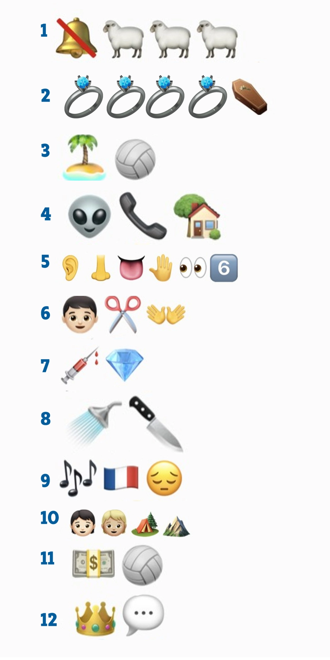
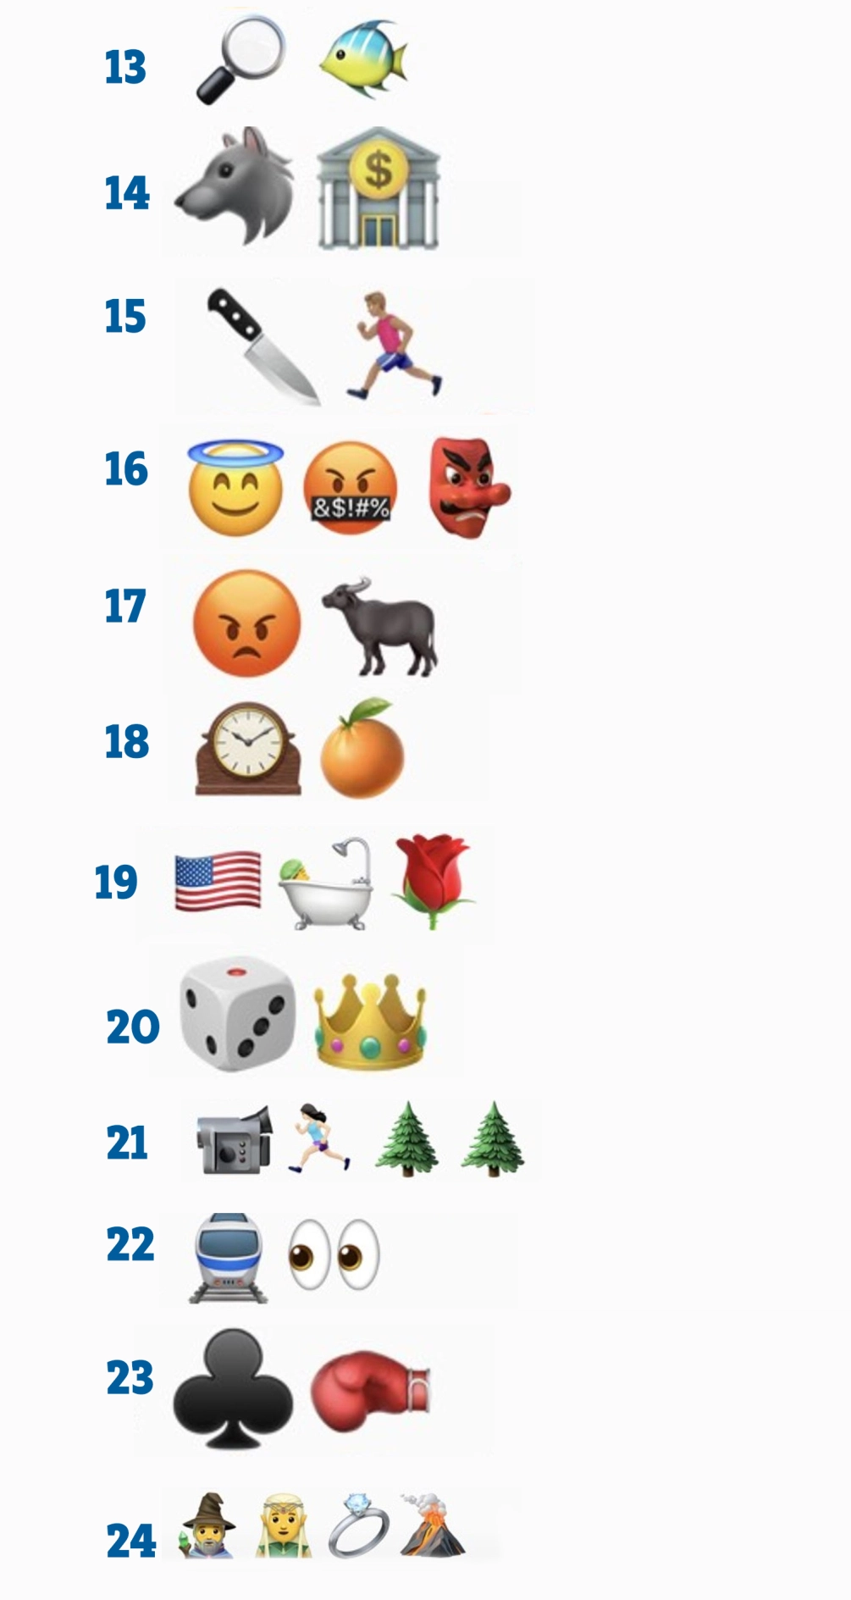
- Silence of the Lambs
- Four Weddings and a Funeral
- Castaway
- E.T.
- The Sixth Sense
- Edward Scissorhands
- Blood Diamond
- Psycho
- Les Miserables
- Brokeback Mountain
- Moneyball
- King's Speech
- Finding Nemo
- Wolf Of Wall Street
- Blade Runner
- The Good, The Bad and The Ugly
- Raging Bull
- A Clockwork Orange
- American Beauty
- Casino Royale
- The Blair Witch Project
- Trainspotting
- Fight Club
- Lord of the Rings

1.

2.

3.

4.

5.

6.

7.

8.

9.

10.

11.

12.
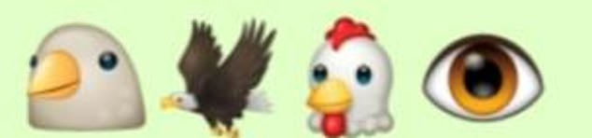

13.

14.

15.

16.

17.

18.

19.

20.

21.

22.

23.

24.

25.

26.

Answers:
1. Walkers
2. Hellmann’s
3. Pot Noodle
4. Cornflakes
5. Blue Dragon
6. Doritos
7. Burger King
8. Cathedral City
9. Starbucks
10. Nandos
11. Tango
12. Birds Eye
13. Twister Ice Lolly
14. Dr Pepper
15. Crabbies
16. Pizza Express
17. Fox’s Party Rings
18. Lipton
19. Fever Tree
20. Old Jamaica
21. Red Bull
22. Babybel
23. Angel Delight
24. 7 Up
25. Carte D’or
26. Heinz

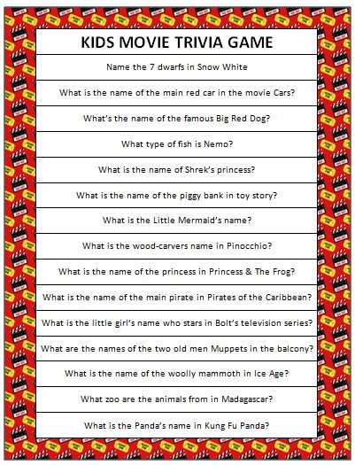

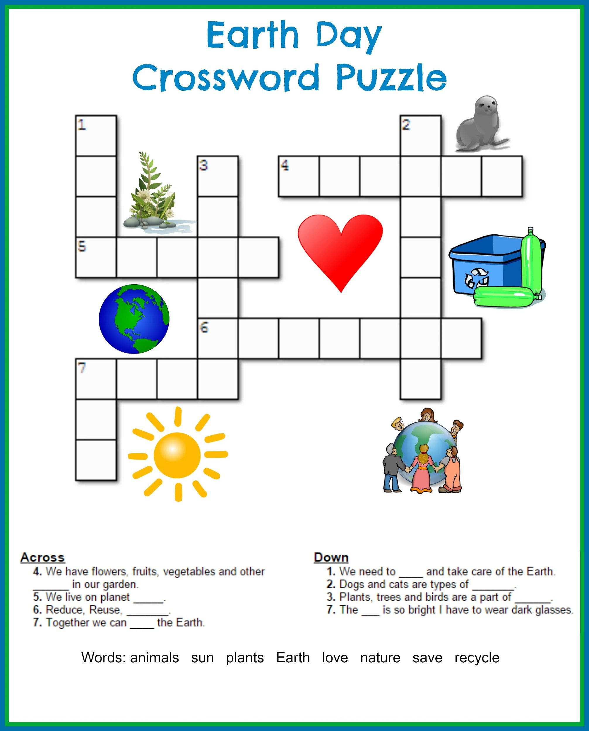
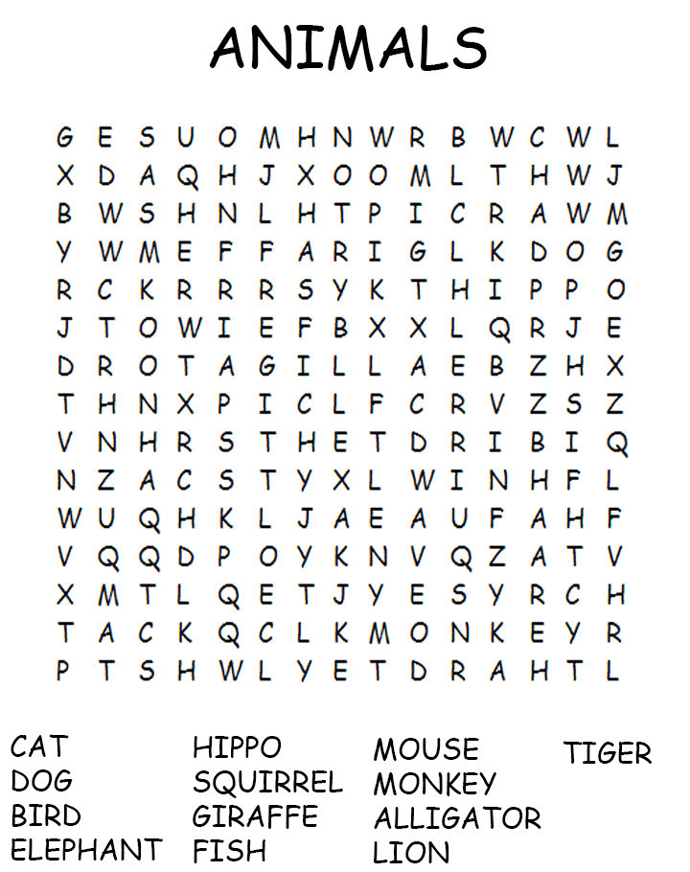

Who can get to the end first? 1, 2, 3 GO!!

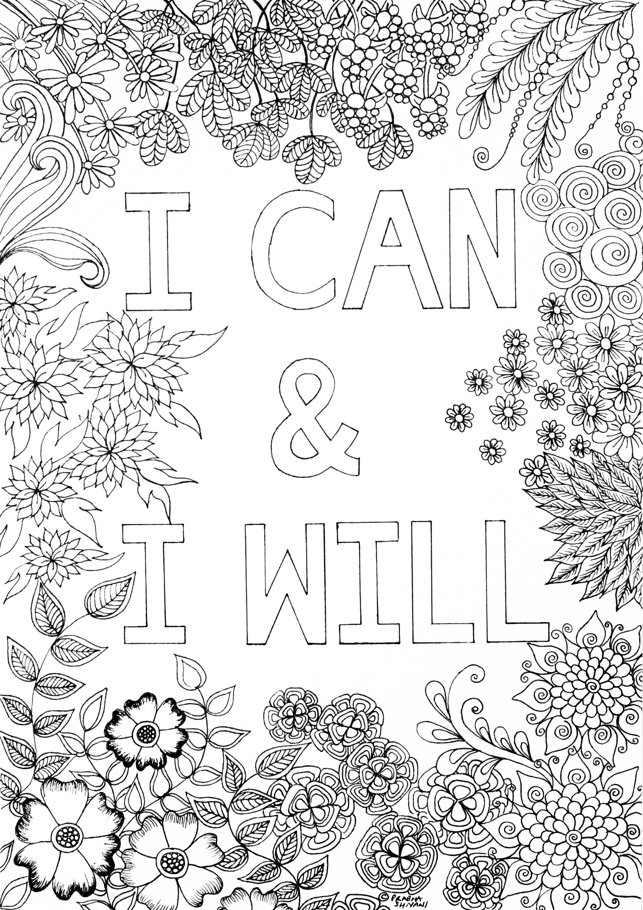
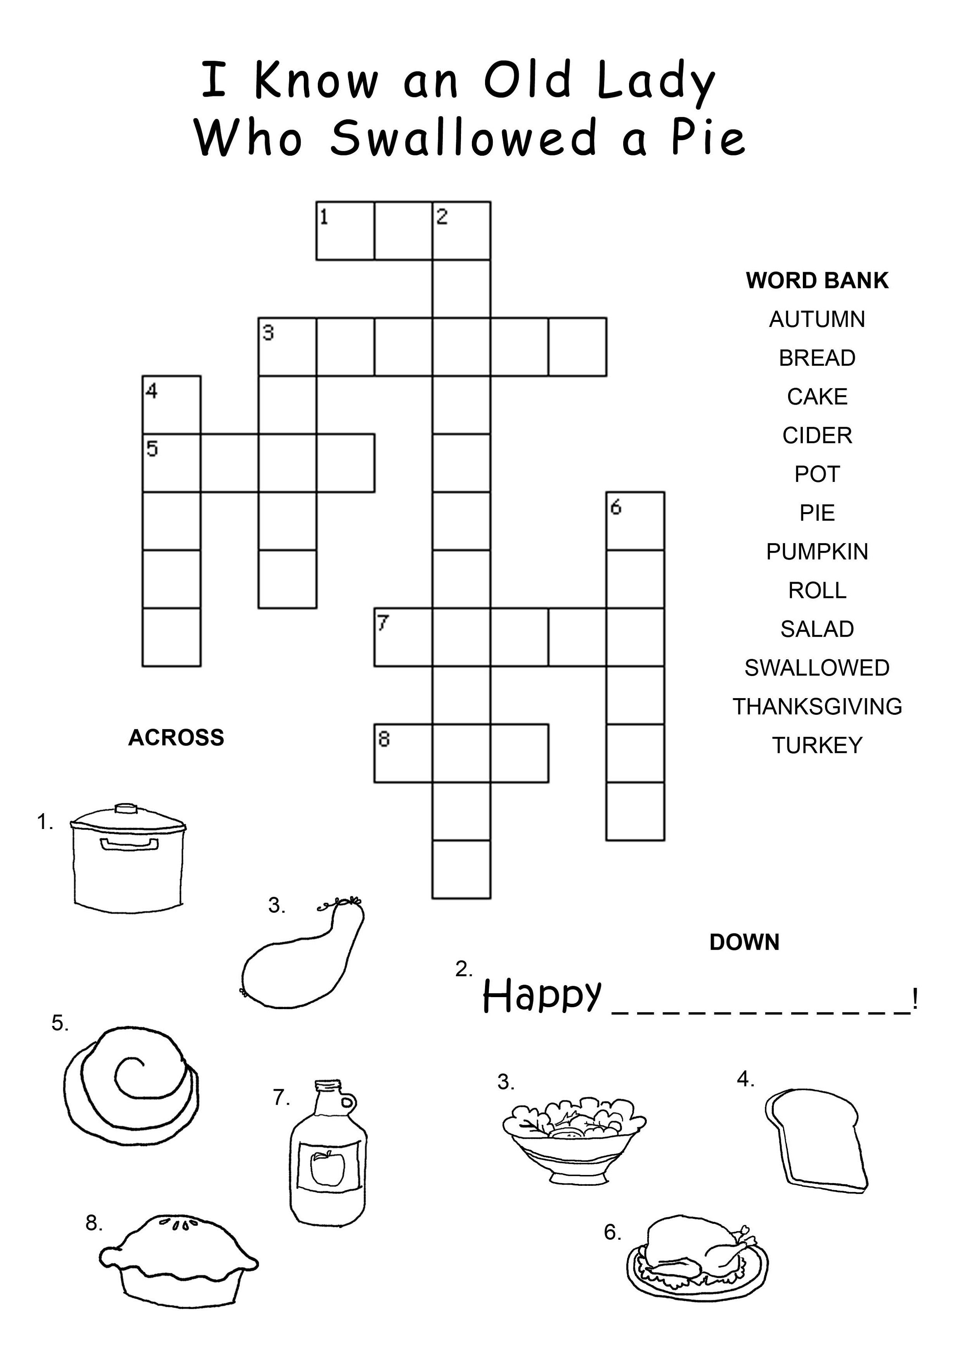

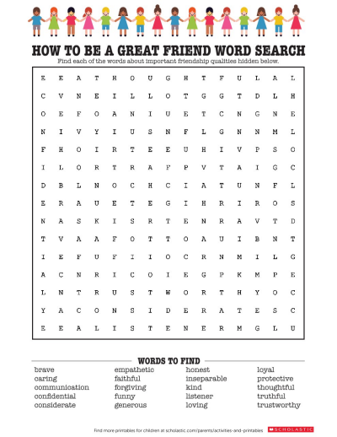

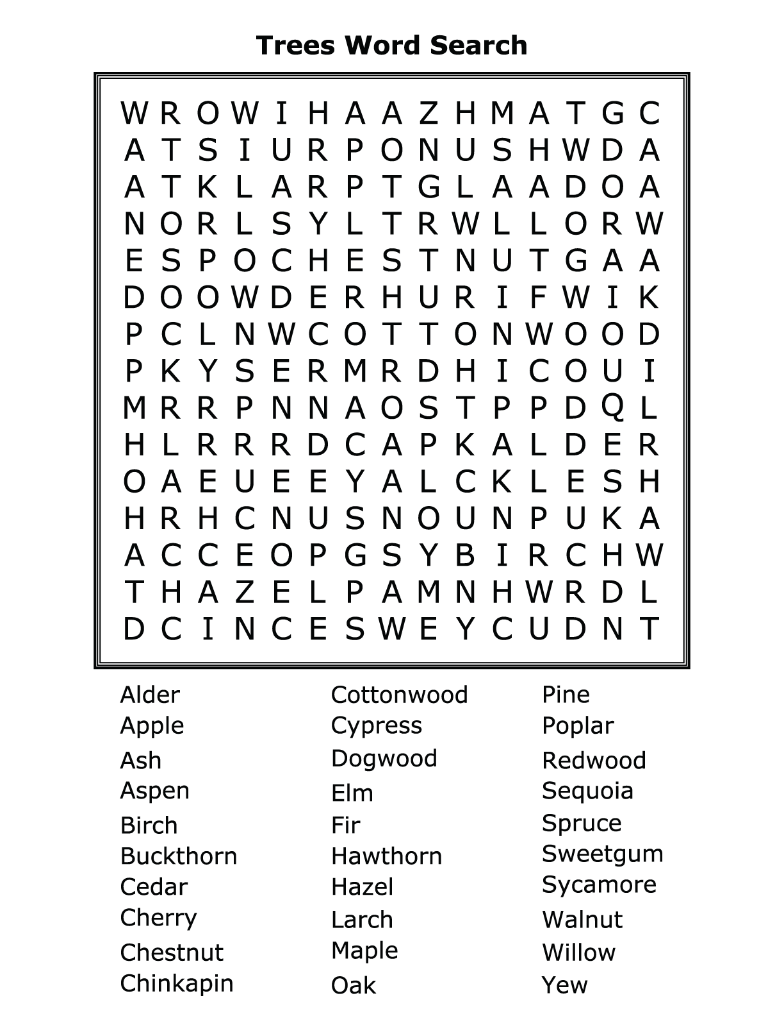

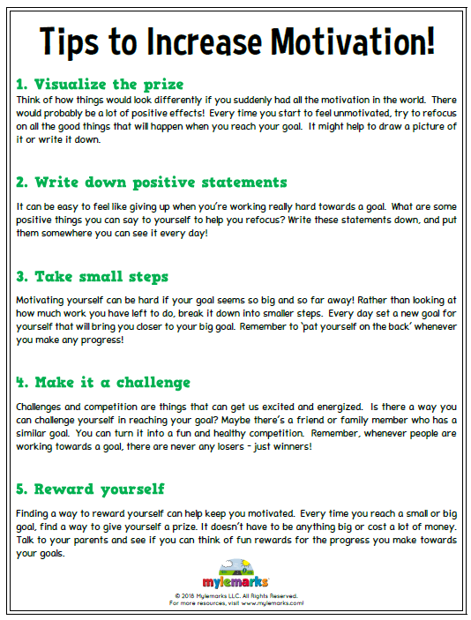
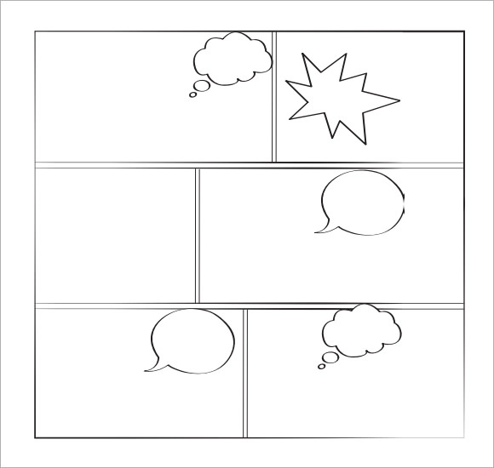

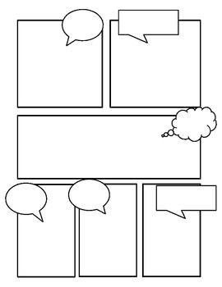

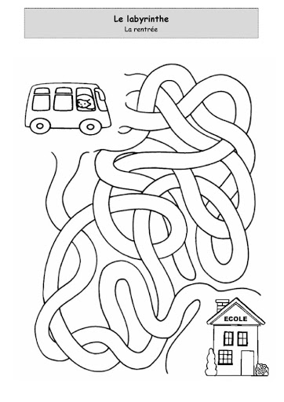
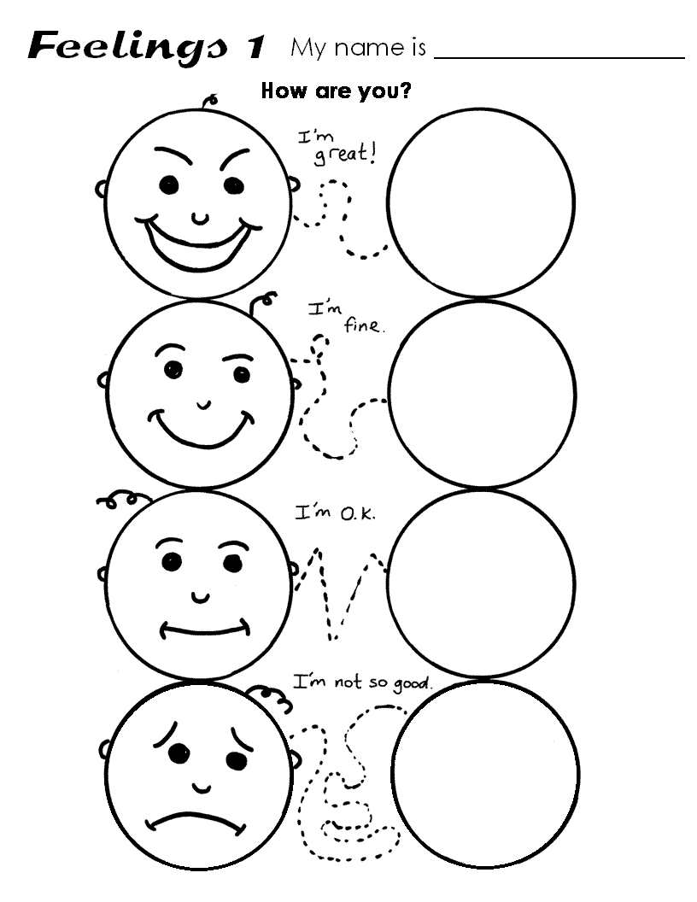

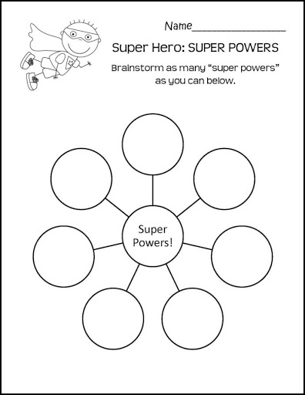

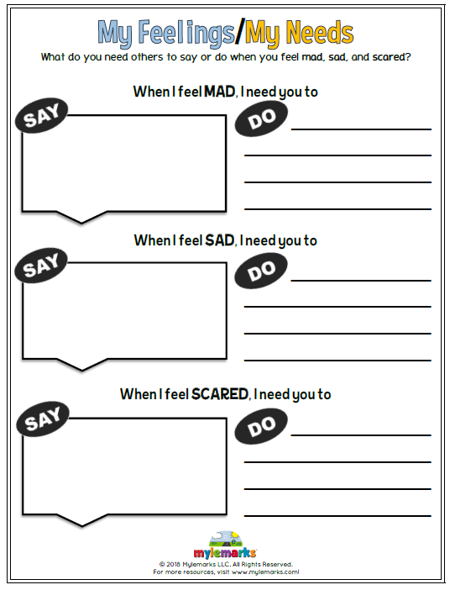

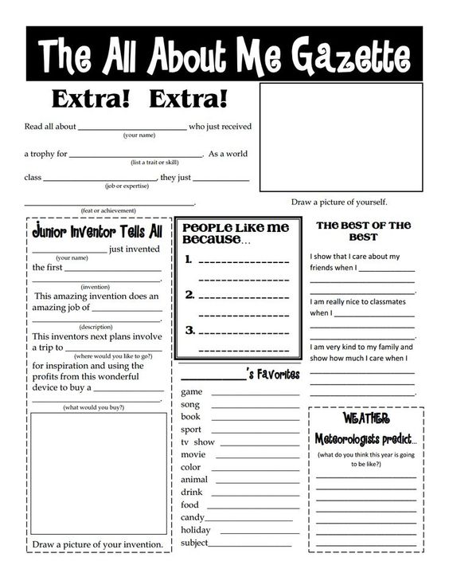
MINDFULNESS
Exercise 1
Mindful breathing
This is a basic form of mindfulness meditation whereby the primary focus is to become aware of our breath. We learn to observe our thoughts, without dwelling on them or resisting them. The goal of this exercise is calmness and acceptance of the present moment.
- Sit comfortably in a chair or on a cushion or mat. Keep your spine straight without arching your back.
- Direct your attention to your breathing. Observe the sensations as you inhale and exhale. Try and inhale to a count of five and exhale to a count of five.
- Place your fingers on your chest and feel your diaphragm expand with each inhalation and deflate with each exhalation.
- As thoughts come up, acknowledge them and return your attention to your breath. It is natural for your attention to wander off and this may happen frequently at first. Simply notice that your attention has wandered off and bring it back to your breath.
Tip: It is not necessary to alter your natural breathing. Simply observe your breath without judgement.

Exercise 2
Breathing meditation
- Sit comfortably in a chair or lie down. If you choose to sit, keep your spine straight without arching your back. Let your shoulders drop; do not hunch them.
- You may close your eyes if you wish or you can keep them open. Place your hands lightly on your abdomen.
- Observe and feel the gentle rise and fall of your abdomen with the in-breath and out-breath. Direct your attention to your breath and ride the breath as if you are riding a wave.
- As your mind wanders away from your breathing, as it will tend to, simply notice the thought that distracted it and bring your attention back to your breathing. Even if your thoughts distract you several times, simply bring your awareness back to your breathing, without judging the thought or dwelling on it.
Tip: Begin by incorporating fifteen minutes of breathing meditation daily.

Exercise 3
Breathing meditation at different times of the day
- Tune in to your breath at random times of the day and observe your abdomen rising and falling through three or four breath cycles.
- At these times, pay conscious attention to your thoughts and bodily sensations.

Exercise 4
Visualisation meditation during times of stress
Mindfulness can be used during distressing bodily sensations, emotions or thoughts, to view ourselves from a broader perspective.
- Think of your mind as a large lake or ocean.
- There are always waves on the surface of the lake or ocean.
- Imagine yourself riding the waves of stressful thoughts and allowing them to flow away, rather than getting involved with them.
- Stay with any distressing thoughts or feelings and gently allow them to flow away without dwelling on them.
Tip: Avoid trying to resist distressing thoughts. Acknowledge their presence and label them.

Exercise 5
Meditation technique for anxiety
Chronic anxiety can severely impact daily activity and limit your potential. Anxiety can manifest itself in the form of several symptoms, such as fatigue, sleeplessness, irritability, headaches and even stomach disorders. Meditation helps quieten the frenzy of racing thoughts and helps you stay grounded during times of stress.

Exercise 6
Deep breathing technique
- Sit comfortably with your back straight but not arched. Drop your shoulders. Place one hand lightly on your chest and the other on your abdomen.
- Breathe in through your nose and feel your abdomen rise. Your chest will rise very little in comparison with the abdomen.
- Exhale through your mouth, using the muscles of the abdomen. Be gentle; there should be no pain.
- Continue to inhale through your nose and exhale through your mouth and count each breath. Direct your attention to your hands on your abdomen and chest. When you notice your thoughts wandering away, gently return your attention to your breathing.
If you are not comfortable sitting in a chair, try lying down on the floor. Place a small book on your abdomen and observe it rise with every breath.
This exercise can be performed at any time of the day.

Exercise 7
Concentration meditation 1
In this form of meditation, the participant chooses an object on which to focus their attention. For example, you can choose a lighted candle or a flower. Observe the object with each breath and centre yourself at each moment.
For example, if you have selected a flower as your object of attention, notice its colours, shape and petals. Each time you notice your attention wandering, bring it back to the flower in front of you.
Tip: Instead of a physical object, you may also choose to meditate on a mental image. For example, you may wish to imagine a tree or a symbol and focus your attention on it.

Exercise 8
Concentration meditation 2
Start with the breathing meditation. However, instead of returning your attention to your breath, allow it to rest at will, provided you are fully engaged. Hence, your attention may rest on a thought, a sensation, your breath and then a feeling and so on. It is alright to allow your awareness to rest at will, as long as you are fully aware of where it is resting.
If you feel ‘spaced out’, simply bring your attention back to your breathing.

Exercise 9
Progressive muscle relaxation meditation
- Sit comfortably in a chair. Alternatively, you can lie down.
- You can choose to keep your eyes closed or open.
- Direct your attention to your feet. Whilst inhaling, gently squeeze your right foot, hold it for seven to ten seconds and then release it. Observe the sensations as you exhale and release the stored tension.
- After completing the above step with both feet, bring your attention to your calves, inhale and squeeze your calf muscles, hold and release. Exhale and feel the tension being released.
- Repeat the same process of squeezing and holding on the in-breath and releasing on the outbreath. Move slowly upwards to your thighs, hips, abdomen, chest, shoulders, arms and neck.
Whilst performing a progressive muscle relaxation meditation, pay attention, without judgement, to:
- The sensation of your muscles at rest;
- The sensation of your muscles whilst contracted;
- The sensation of your muscles as you relax them;
- The sensation of your muscles when they are deeply relaxed.

Exercise 10
Body scan meditation technique for stress relief
- Lie down comfortably or sit in a chair.
- Take slow, deep breaths to relax the mind.
- Consciously bring your attention to your right foot. Observe any sensations that you notice. For example, you may notice pain, soreness or dryness. Do not judge the sensation, simply label it and release it.
- Imagine yourself breathing from the right foot and stay with this awareness for several seconds.
- Now move your attention to your left foot. Repeat the process in the above step.
- Now move your attention to your shins, calves, knees, thighs, etc. and imagine yourself breathing from that part of the body.
- If there are any areas of the body that are causing discomfort or pain, stay with those parts of the body for a few seconds longer. Imagine yourself breathing from them. Pay close attention to all the parts of your body, one by one, including the neck, chin, jaw, ears, eyes, forehead, temples and scalp.
When you complete a full body scan, take a few minutes to re-centre yourself.

- Exercise 11
Alternate nostril breathing Sit in a comfortable position with your back straight.
- Use the middle finger of your right hand to lightly cover your left nostril. Breathe in and out through your right nostril.
- Now cover your right nostril with your left middle finger. Breathe in and out through the left nostril. Continue to inhale and exhale through alternate nostrils.
- Sit in a comfortable position with your back straight.
- Use the middle finger of your right hand to lightly cover your left nostril. Breathe in and out through your right nostril.
- Now cover your right nostril with your left middle finger. Breathe in and out through the left nostril. Continue to inhale and exhale through alternate nostrils.
You can try starting with five complete rounds and work your way up to ten.
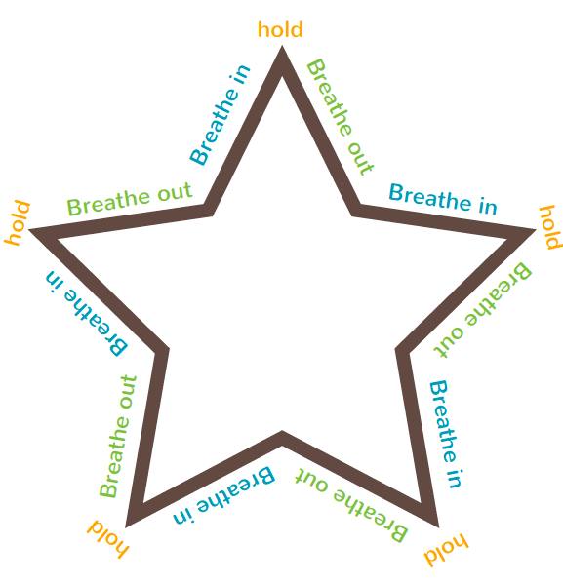

OTHER IDEAS
- During your session you asked your student to draw some pictures which start with the letters of their names. Then they have to make a word from each letter and write a short story including those words.

- Show & Tell– Have students take turns sharing something special to them.

- Two Truths & a Lie– You can take turns sharing 2 truths about yourselves and see if you can work out each other’s truth or lie. A great ‘getting to know’ you game.

- Would You Rather…– You can grab some “Would You Rather” (See previous resource)

- Pet Parade – Your student can bring their pet (real or stuffed) to your meeting and share some interesting facts about their pet when it is their turn.

- LEGO Challenge - If your student has access to Lego you could ask them to build something and bring it to your next session. Students can take turns showing their models and sharing what they like best about it. Or, you could set a challenge for them to build a specific thing…building a boat that floats, build a model of your room, build a marble run, build a pyramid, etc.

- Art Show – Ask your students to create their own piece of artwork (or two) and share with you during your session.

- Poem Promise – You could try to create a funny poem together about any subject.

Movement/Pausing Activities
Maybe try some mindfulness activities or stretches if the student is lethargic. (See above)
Your student may need brain breaks, maybe just sit together and have a drink and snack and just have a chat.

If you need any more resources, please let us know and we will send them over so we can support you with your sessions.
Always remember just logging on and being present can be enough. You are all doing a fantastic job and making a huge difference to your students, even if some days it may not feel like it. 😊

