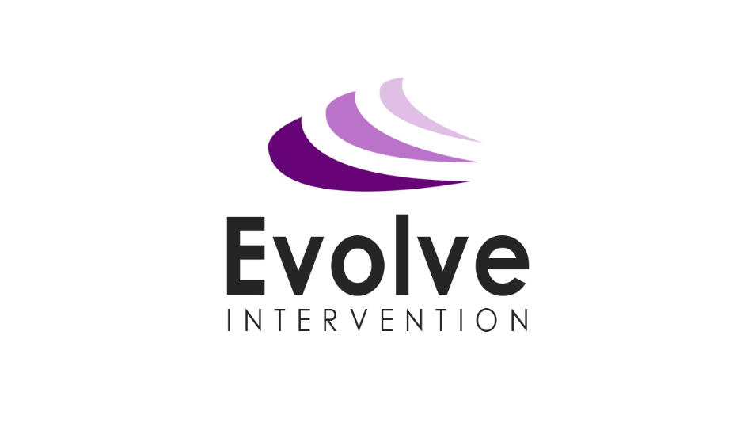

EVOLVE INTERVENTION

Staff Wellbeing Policy

August 2020

Date Created | 1st September, 2018
Date last reviewed | 20th August, 2020
Date to be reviewed | 1st September, 2021
Written by | Emma Prince, Director

- Introduction
Evolve Intervention wishes to ensure that staff and volunteer wellbeing is protected, maintained and prioritised at the core of our practice.

- Aims

  - To develop a healthy, motivated workforce who are able to deliver a high-standard of intervention to children and young people.
  - To help ensure that Evolve Intervention promotes the health and wellbeing of all staff members, recognising the impact work can have on employees’ stress levels, mental and physical health.
  - To recognise that excessive hours of work can be detrimental to staff health and effectiveness and to agree on flexible working practices where possible without damaging opportunities for the children and young people in receipt of our interventions to succeed.
  - To communicate the importance of a work-life balance to all staff, and to ensure that all policy updates are communicated regularly.
  - To respond sensitively to external pressures which affect the lives of staff members.
  - To provide staff with training to deal positively with stressful incidents, and provide them with a sense of confidence to deal with emergencies via training.
  - To improve staff development, co-operation and teamwork by creating effective leaders.
  - To make staff members aware of the channels which can be used to manage and deal with stress or work related health and wellbeing issues.

- Roles and Responsibilities

  - The Director:
    - Will take overall responsibility for implementing this policy and ensuring that staff enjoy a reasonable work-life balance and lead by example in this regard.
    - Will adopt the appropriate policies in respect of ‘family friendly’ employment, including consideration of part-time working, flexible working patterns etc., where this can be implemented without detriment to the operational requirements of the organisation.
    - Will ensure that clear procedures are in place that will minimise the levels of stress caused to staff when following formal procedures such as the Capability or Disciplinary Policy.
    - Will provide a range of strategies for involving staff in the organisation’s decision making processes and ensure there is always clear communication
    - Will review the demands on staff, and seek practical solutions wherever possible.
    - Will ensure staff have access to monthly clinical supervision.
    - Will provide personal and professional development such as stress management, team building, etc.
    - Will create reasonable opportunities for employees to discuss concerns, and will enable staff to do so in an environment where stress is not considered a weakness.
    - Will ensure that individual interventions such as short-term rehabilitation and return to work plans, and longer-term reasonable adjustments to work are in place if needed

  - Staff and Volunteers:

    - Will make themselves aware of the Evolve Intervention’s policies on Capability, Bullying and Harassment, Staff Attendance etc.
    - Will assist in the development of good practice and ensure that they do not, through their actions or omissions, create unnecessary work for themselves or their colleagues.
    - Will ask their Line Manager for help or support if required. This includes understanding that a good relationship requires communication from both parties and so it’s important that issues are raised at the earliest possible moment so that effective strategies can be put in place to manage workloads.
    - Will identify opportunities for development and take advantage of those offered by the organisation.
    - Will apply for any requests for leave of absence in advance and be honest about sickness absence leaves.
    - Will complete an annual Wellbeing Action Plan (WAP) as part of their annual review with their Line Manager.
    - Will share their views, ideas and feelings about all issues concerning the organisation at formal meetings and informal gatherings.

- Support

  - Actions to support new staff

    - All staff will be required to attend an introductory meeting with the Director
    - All new staff will receive the staff induction pack/staff handbook. This will continue to include all important policies, or their location.
    - All staff will be made to feel welcome and given as much support as required.
    - All staff are to be issued with an ID badge as part of their induction.
    - At the end of the first week of employment, new staff will have a review with their Line Manager.
    - All new staff will have a 3-month review interview with their Line Manager. Additional reviews may be scheduled at 6-months and/or a year.

  - Procedures for handling issues of wellbeing

    - The Director and other managers must encourage the creation and maintenance of an atmosphere where all staff members feel comfortable asking for help or raising concerns. They should be sensitive to any problems which may cause the employee stress-related issues and should act in a professional, fair, consistent and timely manner when a concern arises.
    - Where additional, professional advice is required, the organisation must secure this through Occupational Health Professionals and Human Resource experts and ensure appropriate avenues are utilised
    - Where necessary, staff should be encouraged to use the confidential counselling service listed in The Staff Handbook. This service provides staff with serious concerns to obtain advice and support outside of the workplace.
    - Evolve Intervention will provide support to any employees facing high-levels of stress in the workplace, as well as other work-related issues which are having/have the potential to have negative impacts on the staff member’s health and wellbeing. The various options for dealing with such issues should be discussed with staff members where appropriate. In some cases, this may include external support.
    - During this time, the Evolve Intervention will ensure that at all times the staff member’s privacy and dignity is respected. This means maintaining confidentiality, upholding the employee’s rights and dealing with the employee with tact and sensitivity.

  - Procedures to promote staff wellbeing

    - Weekly staff briefing via email.
    - Half termly staff meeting.
    - Continuing professional develop for all staff.
    - Quarterly social events.
    - Performance management.
    - Annual job description reviews.
    - Annual Wellbeing Action Plan completion.
    - Offer of monthly clinical supervision.
    - Recognition on staff birthdays/special occasions.
    - Quarterly consultative staff meetings held to give staff the opportunity to voice concerns and to have their views sought.

- Policy Review
The Director is responsible for the annual review of this policy. It is renewed every year or whenever deemed necessary. This policy was written by Emma Prince, Director, 20th August, 2020.

