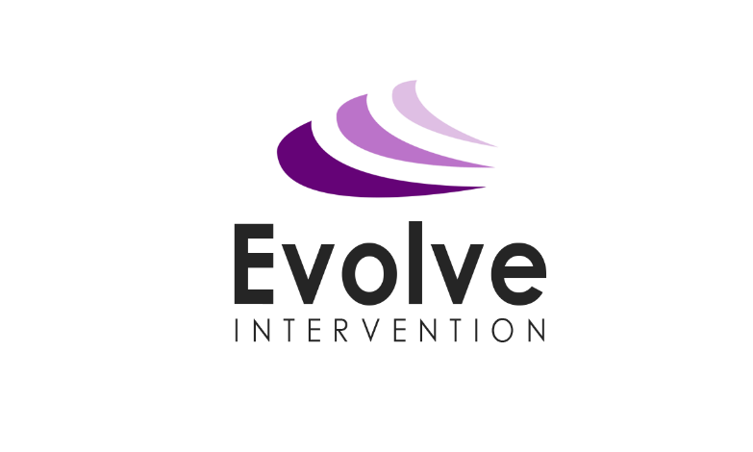

EVOLVE INTERVENTION

Staff Code of Conduct Policy

August 2020

Date Created | 3rd September 2017
Date last reviewed | 20th August, 2020
Date to be reviewed | 1st September, 2021
Written by | Emma Prince, Director

Staff Code of Conduct

- Aim, Scope and Principles

This policy aims to set and maintain standards of conduct that we expect all staff to follow (including Volunteers). By creating this policy, we aim to ensure our staff and services users experience an environment where everyone is safe, happy and treated with respect. Evolve Intervention staff have an influential position in their delivery of interventions, and will act as role models for children and young people by consistently demonstrating high standards of behaviour. We expect that all staff and volunteers act with personal and professional integrity, respecting the safety and wellbeing of others. Failure to follow the code of conduct may result in disciplinary action being taken, as set out in our staff disciplinary procedures. Please note that this code of conduct is not exhaustive. If situations arise that are not covered by this code, staff will use their professional judgement and act in the best interests of the organisation and service users.

- Legislation and Guidance

In line with the statutory safeguarding guidance and legislation, we should have a staff code of conduct, which should cover acceptable use of technologies, staff/service user relationships and communications, including the use of social media.

- General Obligations

Staff set an example to service users (children and young people). They will:
- Maintain high standards in their attendance and punctuality
- Never use inappropriate or offensive language in during intervention delivery or other contact with service users
- Treat others with dignity and respect
- Show acceptance and respect for the rights of others
- Not undermine fundamental British values, including democracy, the rule of law, individual liberty and mutual respect, and respect of those with different faiths and beliefs
- Express personal beliefs in a way that will not overly influence service users, will not exploit service users’ vulnerability or might lead them to break the law
- Understand the statutory frameworks they must act within

- Safeguarding

Staff have a duty to safeguard children and young people from harm, and to report any concerns they have. This includes physical, emotional and sexual abuse, or neglect (including any concerns around FGM, Prevent and financial abuse). Staff will familiarise themselves with our safeguarding policy and procedures and ensure they are aware of the processes to follow if they have concerns about a child. Our safeguarding policy and procedures are available on our shared area and are emailed to all staff as a soft copy as part of their induction, as well as after any updates.

- Staff/service user relationships

Staff will observe proper boundaries with children and young people that are appropriate to their professional position. They will act in a fair and transparent way that would not lead anyone to reasonably assume they are not doing so. Where staff members and service users must spend time on a one-to-one basis, staff will ensure that:
- This takes place in a place that others can access
- Others can see in to the room
- A colleague or line manager knows this is taking place
Personal contact details should not be exchanged between staff and service users. This includes social media profiles. If a staff member is concerned at any point that an interaction between themselves and a service user may be misinterpreted, this should be reported to their Line Manager or the Director of the company, Emma Prince.

- Communication and social media

Evolve Intervention staff’s social media profiles should not be available to service users. If they have a personal profile on social media sites, they are advised not to use their full name, as service users may be able to find them. Staff should consider using a first and middle name instead, and set public profiles to private. Staff should not attempt to contact service users or their parents via social media, or any other means outside of the intervention, in order to develop any sort of relationship. They will not make any efforts to find service users’ or parents’ social media profiles. Staff will ensure that they do not post any images online that identify children who are service users of Evolve Intervention without liaising with the Director (Emma Prince) regarding obtaining consent appropriately. Staff should be familiar with and refer to our Social Media policy and Electronic Information and Communication Systems Policy.

- Confidentiality
In the course of their role, members of staff are often privy to sensitive and confidential information about the organisation, staff, referrers, service users and their parents. This information will never be:
- Disclosed to anyone without the relevant authority
- Used to humiliate, embarrass or blackmail others
- Used for a purpose other than what it was collected and intended for
This does not overrule staff’s duty to report child protection concerns to the appropriate channel where staff believe a child is at risk of harm. Staff should be familiar with and refer to our Safeguarding and Child Protection policy and our Data Protection policy.

- Honesty and integrity
Staff should maintain high standards of honesty and integrity in their role. This includes when dealing with service users, handling money, claiming expenses and using property and facilities. Staff will not accept bribes. Gifts that are worth more than £20 must be declared and recorded on the gifts and hospitality register. Staff will ensure that all information given to the Evolve Intervention about their qualifications and professional experience is correct.

- Dress code

We encourage everyone to maintain an appropriate standard of dress and personal appearance at work and to conduct themselves in a professional manner. The purpose of our dress code is to establish basic guidelines on appropriate clothing and appearance at our workplace, so that we:

(a) promote a positive image and staff look professional;
(b) respect religious, racial and gender-specific clothing requirements and those of staff with disabilities where possible;
(c) take account of health and safety requirements; and
(d) help staff decide what clothing it is appropriate to wear to work.

We expect staff to take a common sense approach to the dress code. Any enquiries regarding the operation of our dress code (including whether an article of clothing is suitable to wear to work) should be made to your Line Manager.

Business clothing is the best guide and casual clothing should be avoided. Staff have the option to request an Evolve Intervention polo shirt. Outfits will not be overly revealing, and we ask that tattoos are covered up. Facial piercings should be removed whilst representing the organisation. Clothes will not display any offensive or political slogans.

- Conduct Outside of Work
Staff will not act in a way that would bring the organisation into disrepute. This covers relevant criminal offences, such as violence or sexual misconduct, as well as negative comments about the organisation on social media.

- Review
This policy will be reviewed every 2 years, but can be revised as needed.

